AI-Augmented Backend Development Project :

TITLE : AI Study Buddy

Project Description

In a Single Paragraph
AI Study Buddy is an AI-Augmented backend Web Application developed using the (MongoDB, Express.js,Node.js) integrated with Artificial Intelligence capabilities such as Large Language Models (LLMs), Semantic Search, Vector Search, and Intelligent Recommendations. The system enables users to interact with data through natural language, receive AI-generated insights, perform semantic searches, upload and analyze documents, and automate decision-making processes. By combining traditional backend development with modern AI technologies, the platform delivers an intelligent, scalable, and user-friendly experience that improves productivity, accessibility, and operational efficiency.

Scenario
- Students often manage notes, PDFs, textbooks, assignments, and practice questions across different resources. Traditional study methods require students to manually search large amounts of material, prepare summaries, create questions, and identify important topics. This can make revision time-consuming and difficult to personalize.
- AI StudyBuddy addresses this problem by combining a secure backend API with AI-powered study features. Students can upload study materials, ask questions in natural language, search content semantically, generate summaries and quizzes, and receive AI-assisted explanations and study recommendations.
- Problem: Students spend significant time organizing study resources and manually finding answers, summarizing content, and preparing practice questions.
- Need for AI: AI can understand natural-language questions, retrieve relevant study content, summarize large materials, and generate personalized practice content more efficiently than manual processes.
Proposed Solution: AI StudyBuddy provides an AI study assistant using chatbot interaction, question answering, semantic/vector search, document analysis, summarization, quiz generation, and learning insights.AI Chatbot
  - Content Generation
  - Question Answering
  - Semantic Search
  - Vector Search
  - Intelligent Recommendations
  - Document Analysis
  - AI-powered Insights

Structure :
Paragraph 1 – Problem:
Students often struggle to understand difficult topics, find reliable study materials, and get immediate answers to their doubts. They may need to use multiple websites or applications for notes, quizzes, explanations, study schedules, and progress tracking. This makes learning time-consuming and less personalized, especially when preparing for exams or studying independently.
Paragraph 2 – AI Solution:
The AI Study Buddy API provides an intelligent learning assistant that can be integrated into web, mobile, or educational applications. Using AI/LLM technology, it will provide AI question answering, personalized study plans, topic-wise explanations, quiz and flashcard generation, doubt clarification, study recommendations, progress tracking, and smart reminders. The API can process student queries and learning data to deliver personalized and relevant learning support.
Paragraph 3 – Impact:
The application will benefit students, schools, colleges, EdTech platforms, and developers building educational applications. Students can receive faster explanations, personalized learning support, better exam preparation, and organized study assistance in one place. Educational platforms can integrate AI-powered learning features through the API without developing a complete AI system from scratch, making the overall learning process more efficient and accessible.

System Requirements :
To ensure smooth development, deployment, and usage of the < Project Name > AI-Augmented Backend Application, certain system prerequisites must be met.

1. Software Requirements

Operating System
- Windows 10/11
- macOS
- Linux

Node.js (v18 or above)
Provides a runtime environment for frontend and backend development.

npm (v9 or above)
Package manager used for dependency installation.

Express.js
Backend framework used for API development.

MongoDB Community Server / MongoDB Atlas
NoSQL database used to store:
- User Information
- Chat History
- Documents
- Embeddings
- AI Interactions
- Application Data

MongoDB Atlas Search
Provides full-text search functionality.

MongoDB Atlas Vector Search
Enables semantic search using vector embeddings.

AI Service Provider
- OpenAI API
- Gemini API
- Claude API
- Azure OpenAI (Optional) …etc

LangChain / AI SDK
Used for orchestration of AI workflows.

Browser
- Google Chrome
- Mozilla Firefox

Postman
API Testing

Visual Studio Code
Development Environment

Git & GitHub
Version Control

2. Hardware Requirements

Processor
Intel Core i5 (8th Gen+) / AMD Ryzen 5+

RAM
Minimum 8 GB
Recommended 16 GB

Storage
Minimum 5 GB Free Space

Internet Connection
Required for AI API communication

Display
1366 × 768 or above

Project Architecture

Technical Architecture :
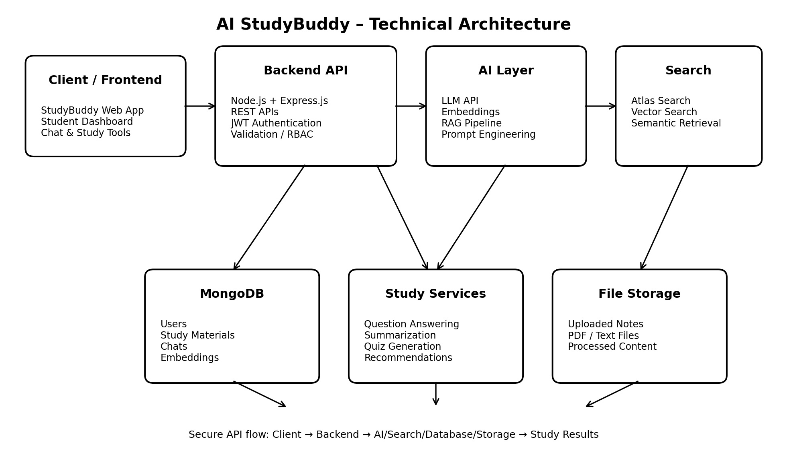

Backend Layer
- Node.js
- Express.js
- JWT Authentication
- REST APIs

Database Layer
- MongoDB
- Atlas Search
- Atlas Vector Search

AI Layer
- LLM APIs
- Embedding Models
- RAG Pipeline
- Prompt Engineering

Storage Layer
- MongoDB Collections
- File Upload Storage

Security Layer
- JWT Authentication
- Protected Routes
- Input Validation
- Role-Based Access Control

ER Diagram
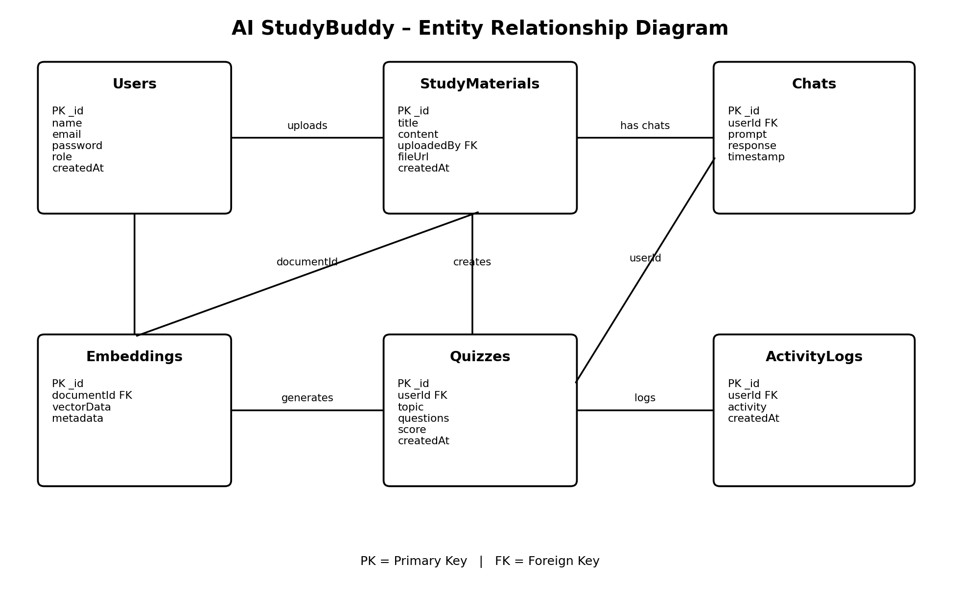

Collections

Users
- _id
- name
- email
- password
- role

Documents
- _id
- title
- content
- uploadedBy
- createdAt

Embeddings
- _id
- documentId
- vectorData

Chats
- _id
- userId
- prompt
- response
- timestamp

ActivityLogs
- _id
- userId
- activity
- createdAt

ER Diagram Explanation
Users can upload documents and interact with AI features. Uploaded documents are processed into vector embeddings and stored in MongoDB. Chat interactions and AI responses are logged for future reference and analytics. Activity logs maintain user actions across the system.

Features

Core Backend Features
- User Registration
- User Login
- JWT Authentication
- Protected Routes
- Middleware
- CRUD API
- File Upload
- Role-Based Access Control

AI Features
- AI Chat Assistant
- Semantic Search
- Vector Search
- Document Question Answering
- Text Summarization
- Content Generator
- RAG (Retrieval Augmented Generation)
- Intelligent Insights
- Natural Language Queries

Roles and Responsibilities

Admin
- Manage Users
- Manage Documents
- Monitor AI Usage
- View Analytics
- Configure System

User
- Register/Login
- Upload Documents
- Ask Questions
- Search Content
- View AI Recommendations
- Manage Personal Data

User Flow
- User Registration
- User Login
- JWT Authentication
- Dashboard Access
- Upload Documents
- Generate Embeddings
- Store Vectors in MongoDB
- User Query Submission
- Semantic Search Execution
- AI Response Generation
- Display Results
- Store Chat History

MVC Pattern
The backend follows the MVC (Model-View-Controller) architecture.

Model Layer
Responsible for:
- User Schema
- Chat Schema
- Document Schema
- Embedding Schema
- Activity Schema
Implemented using Mongoose.

Controller Layer
Responsible for:
- Authentication Logic
- AI API Integration
- Document Processing
- Embedding Generation
- Search Operations
- CRUD Operations

View Layer (Routes)
Defines REST API endpoints:

Authentication Routes
- Register
- Login
- Logout

AI Routes
- Chat
- Summarization
- Semantic Search

Document Routes
- Upload
- View
- Delete

User Routes
- Profile
- Dashboard

Advantages of MVC
- Separation of Concerns
- Better Maintainability
- Easy Scalability
- Reusable Components
- Team Collaboration
- Easier Testing

Project Setup and Configuration

Project Structure
Create Project Folder
Inside Project Folder:

Server Folder
Backend Application

Server Setup
mkdir server

cd server

npm init -y
Create:
server.js

models/
controllers/
routes/
middlewares/
config/
services/
utils/


Install Backend Packages
npm install express mongoose cors dotenv bcryptjs jsonwebtoken

npm install openai

npm install multer

npm install nodemon --save-dev


Backend Development
Include:
- Authentication APIs
- JWT Implementation
- AI Service Integration
- Vector Search APIs
- CRUD APIs
- Document Upload APIs
- Chat APIs
AI API consumed, including:
- • Purpose: Used to answer student questions, explain difficult concepts, summarize topics, generate study plans, and provide personalized learning assistance.
- • Request Structure: The application sends the student's question or learning request along with relevant context, such as subject, topic, learning level, and optional study content, usually in a JSON request containing messages/instructions.
- • Response Structure: The API returns generated text containing the answer, explanation, summary, study plan, or recommendation. The backend converts this into a consistent JSON response for the client application.
- • Cost Considerations: Cost generally depends on the AI provider, selected model, and amount of input/output processed. The application should reduce unnecessary requests, limit input size, use suitable models for simple tasks, and monitor API usage.
- • Security Practices: API keys must be stored securely as environment variables or in a secrets manager. They must never be exposed in frontend code. Input validation, authentication, rate limiting, HTTPS, and protection of student data should be implemented.

Database Development
Include:
- MongoDB Collections
- Relationships
- Atlas Search Index
- Vector Search Index
- Sample Documents

Project Execution

Step 1: Backend
cd server

npm install


Step 2: Configure Environment Variables
Create .env
PORT=8000

MONGO_URI=mongodb://localhost:27017/ai_augmented_db

JWT_SECRET=your_secret_key

OPENAI_API_KEY=your_api_key


Step 3: Run Backend
nodemon server.js
Backend URL:
http://localhost:8000


Output with Explanation – AI Study Buddy API

1. API Testing

The AI Study Buddy API is tested to verify that all endpoints work correctly and return the expected results. Testing includes authentication, question-answering, quiz generation, study-plan creation, document processing, and recommendation endpoints. Tools such as Postman can be used to test request methods, parameters, status codes, response formats, and error handling.

2. LLM Integration

The application integrates an LLM (Large Language Model) to provide intelligent learning assistance. Student questions and relevant learning context are sent to the LLM through the backend API. The generated response is processed and returned to the application for features such as explanations, summaries, quiz generation, and personalized study assistance.

3. AI Chat Interface

The AI Chat Interface provides students with a conversational way to interact with the Study Buddy. Students can ask questions in natural language and receive AI-generated explanations. The interface can maintain relevant conversation context so that follow-up questions can be answered more effectively.

4. Document Upload

Students can upload study materials such as PDFs, notes, and documents. The backend extracts the text, processes the content, and can divide it into smaller sections for AI processing. The extracted content can then be used for document-based question answering, summarization, quiz generation, and personalized study assistance.

5. Search Results

The Search Results feature helps students find relevant information from uploaded study materials or connected learning resources. Semantic search can be implemented using embeddings and a vector database, allowing the system to identify content based on meaning rather than only exact keywords. Results can include relevant passages, topics, or learning resources.

6. Recommendation Engine

The Recommendation Engine provides personalized learning suggestions based on student activity, subjects, study progress, and previous interactions. AI can recommend topics to revise, quizzes to attempt, learning resources, and suitable study activities. This helps students follow a more organized and personalized learning path.

Demo Video Link
https://drive.google.com/drive/folders/1209PrPJ2zQR2FP8EmrtZKeTefzqaiBZE?usp=drive_link

Source Code Drive Link

https://drive.google.com/drive/folders/1WstUx9YU5WUzrNLpPLOkovtmvSFJhDOb?usp=drive_link

Mandatory Function
- MVC Architecture
- JWT Authentication
- Semantic Search
- MongoDB Atlas Search
- MongoDB Atlas Vector Search
- Prompt Engineering
- AI API Integration
- Role-Based Access Control

